# *VN Krishna swamy naidu college of arts & science for womens*

# **CRM APPLICATION FOR JEWEL MANAGEMENT (DEVELOPER)**

# 

# 

* CRM APPLICATION FOR JEWEL MANAGEMENT – (DEVELOPER)

### COLLEGE NAME - **VN Krishna Swamy Naidu College Of Arts & Science For Womens Mettupalayam**

### COLLEGE CODE – **Bru4b**

### 

* **TEAM ID - NM2025TMID28288**
* **TEAM MEMBERS - 5**
* Team Leader Name – **Adila Asin N**
* **Email** - [adilaasin916@gmail.com](mailto:adilaasin916@gmail.com)
* Team Member **Archana T**
* **Email** – [archanathiru05@gmail.com](mailto:archanathiru05@gmail.com)
* Team Member **Ramya M**
* **Email** – [ramyaramya82146@gmail.com](mailto:ramyaramya82146@gmail.com)
* Team Member **Sangavi C**
* **Email** – [sangavisangavi377@gmail.com](mailto:sangavisangavi377@gmail.com)
* Team Member **Senka S**
* **Email** – [sneha30032006@gmail.com](mailto:sneha30032006@gmail.com)

### CRM Application for Jewel Management - (Developer)

The Jewel Inventory System is a comprehensive software Solution designed to streamline and manage the inventory and sales processes of a jewellery store or a jewellery manufacturer. The system aims to provide an efficient and user-friendly solution to track and control the inventory of various jewellery items, maintain accurate records, and facilitate seamless sales transactions.

* Creating Developer Account
* Creating a developer org in salesforce.

1. Go to <https://developer.salesforce.com/signup>
2. On the sign up form, enter the following details :

[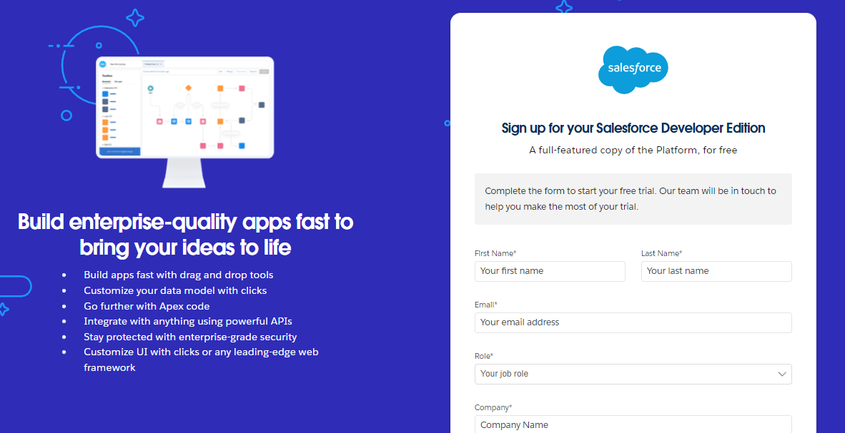](https://developers.salesforce.com/Signup*)

**First name & Last name**

**Email**

**Role-Developer**

**Company- College Name**

**County -India**

**Postal Code- pin code**

**Username should be a combination of your name and company**

**This need not be an actual email id, you can give anything in the format : username@organization.com**

**Click on sign me up after filling these.**

### Account Activation

1. Go to the inbox of the email that you used while signing up. Click on the Reset Password to activate your account. The email may take 5-10mins.
2. Click on Reset Password
3. Give a password and answer a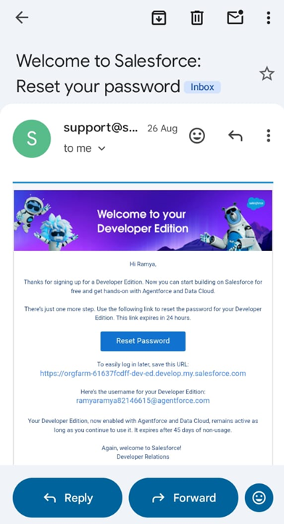 security question and click on change password.

## 

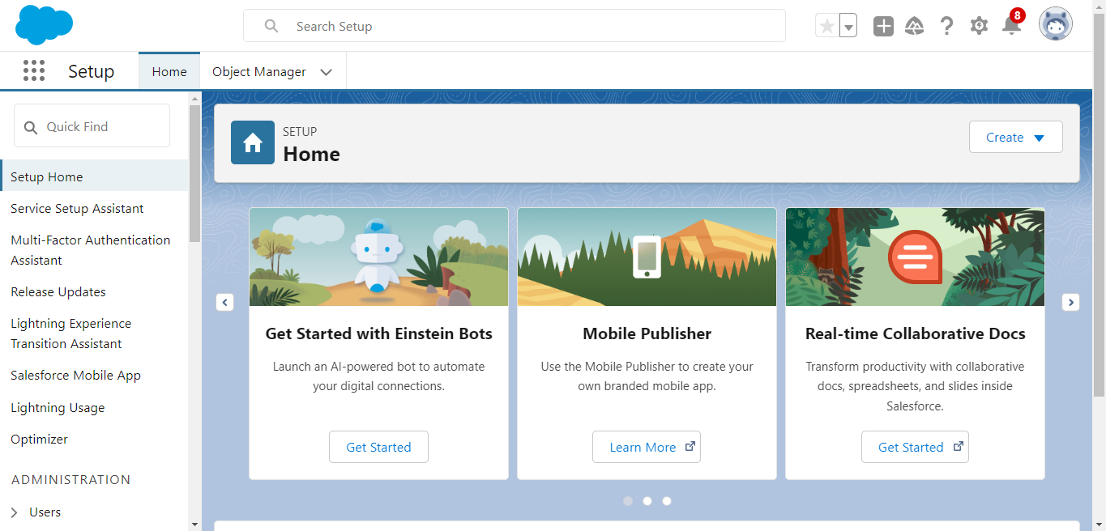

1. Then you will redirect to your salesforce setup page.

# System Modules

## Real Time Salesforce Project

## Data Modelling

## Creating an Application

## User Interface Customization

## Object & Relationship in Salesforce

## Formula fields and Validation rules.

## Field Dependencies

## Record Types

## Cross object formula fields.

## Conditional formatting.

## Flows

## Email alerts and email templates

## Reports & Dashboards

# Objectives

* Improve customer relationships in jewellery business
* Simplify sales and billing processes
* Accurate tracking of jewellery stock (Gold, Silver, Diamond etc.)
* Provide 24x7 customer service
* Support decision-making with Reports & Dashboards

# Tabs

Types of Tabs:

1. Custom Tabs

Custom object tabs are the user interface for custom applications that you build in salesforce.com. They look and behave like standard salesforce.com tabs such as accounts, contacts, and opportunities.

1. Web Tabs

Web Tabs are custom tabs that display web content or applications embedded in the salesforce.com window. Web tabs make it easier for your users to quickly access content and applications they frequently use without leaving the salesforce.com application.

1. Visualforce Tabs

Visualforce Tabs are custom tabs that display a Visualforce page. Visualforce tabs look and behave like standard salesforce.com tabs such as accounts, contacts, and opportunities.

1. Lightning Component Tabs

Lightning Component tabs allow you to add Lightning components to the navigation menu in Lightning Experience and the mobile app.

1. Lightning Page Tabs

Lightning Page Tabs let you add Lightning Pages to the mobile app navigation menu.

Lightning Page tabs don't work like other custom tabs. Once created, they don't show up on the All Tabs page when you click the Plus icon that appears to the right of your current tabs. Lightning Page tabs also don't show up in the Available Tabs list when you customize the tabs for your apps.

Use Case:

Creating Objects and storing Jewels data is the very first step in the requirements they want. Now to access the stored data by an Owner(Gold Smith) in the organisation Admin needs to create Tabs. By designing a dedicated Tab, businesses can improve user experience, simplify navigation, and provide quick access to critical information, enhancing productivity and ensuring efficient utilisation of Salesforce's capabilities.

### Creating a Custom Tab

To create a Tab:(Customer)

1. Go to setup page >> type Tabs in Quick Find bar >> click on tabs >> New (under custom object tab)

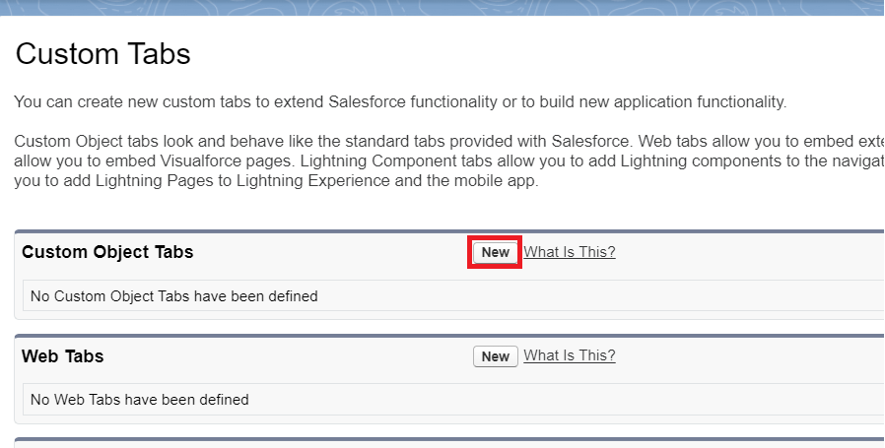

1. Select Object(Jewel Customer) >> Select any tab style >> Next (Add to profiles page) keep it as default >> Next (Add to Custom App) keep it as default >> Save.

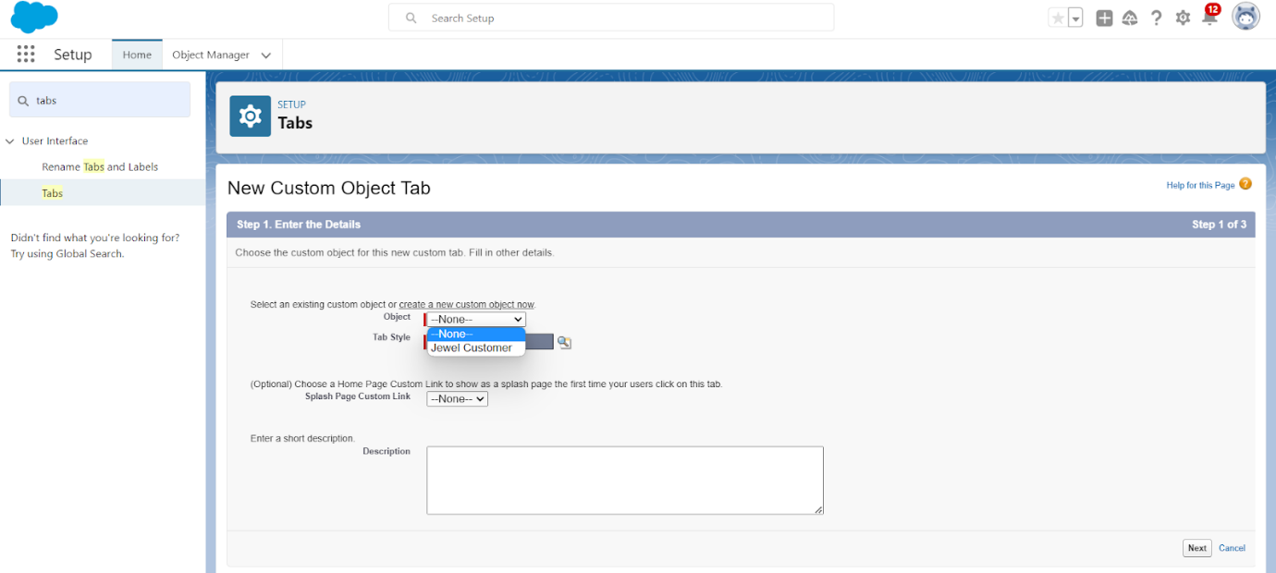

* **Create This Method of Tabs**

# Create a Lightning App

.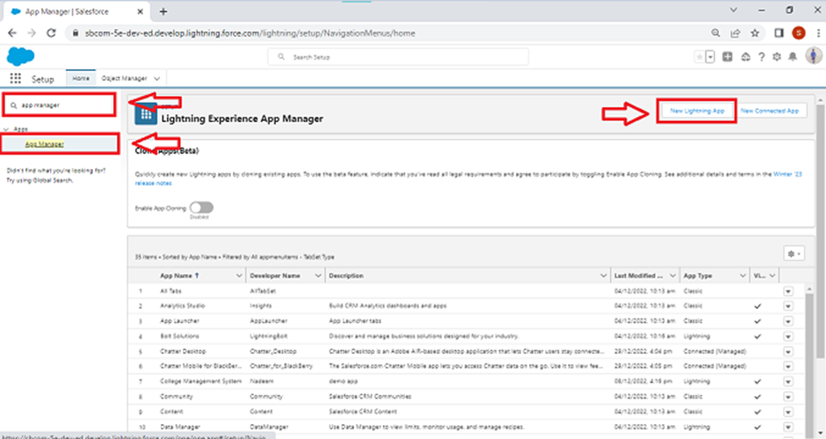

1. Fill the app name in app details and branding as follow  
   App Name : Jewellery Inventory System.  
   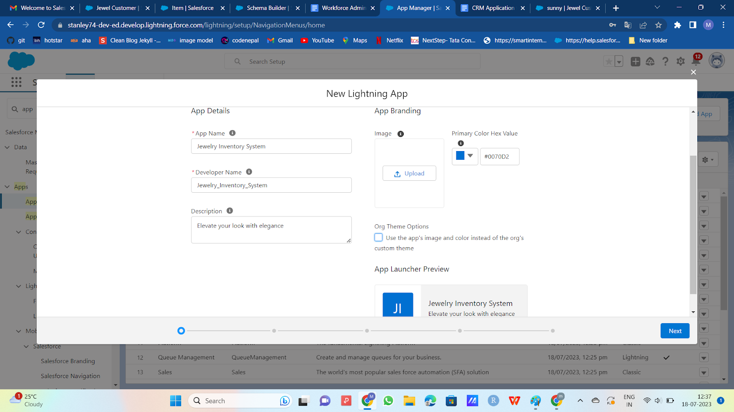
2. Then click Next  >> (App option page)Set Navigation Style as Console Navigation >> Next.

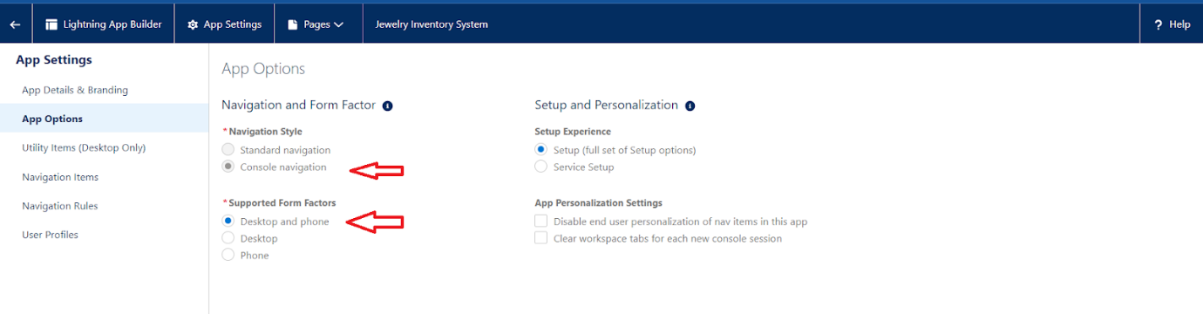

1. (Utility Items) keep it as default >> Next.
2. To Add Navigation Items: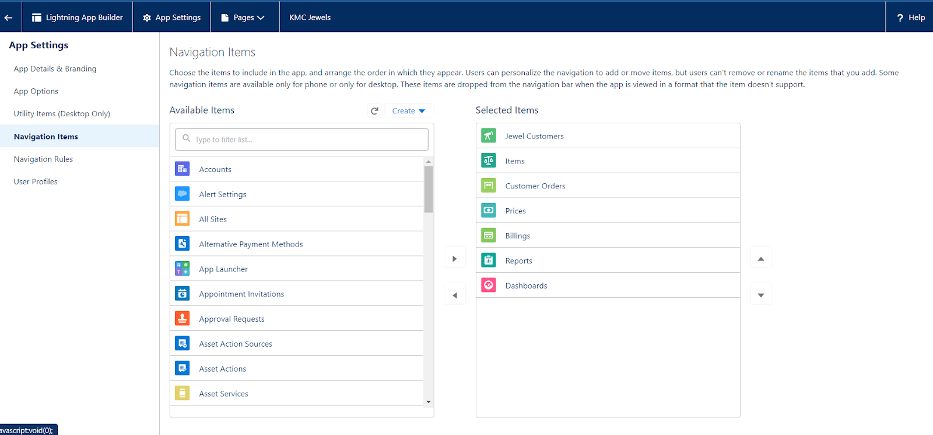  
   Search for the item in the (JewelCustomer,Item,CustomerOrder,Price,Billing,Reports, Dashboard) from the search bar and move it using the arrow button ? Next? Next.
3. To Add User Profiles:

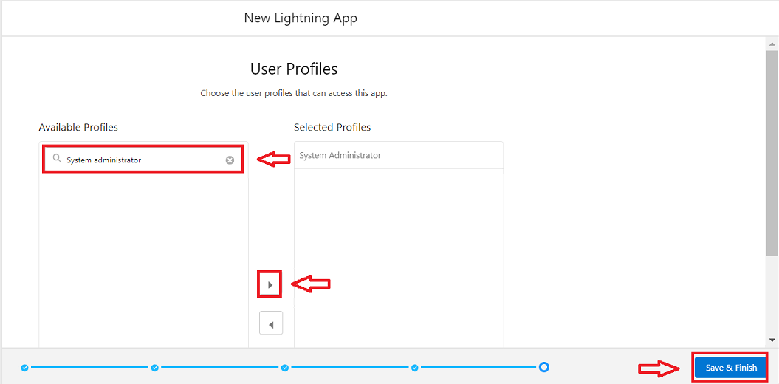

Search profiles (System administrator) in the search bar >> click on the arrow button >> save & finish.

# MODULES

* PROFILE
* ROLE
* USER
* PAGE LAYOUT
* RECORD TYPES
* PERMISSION SET
* TRIGGER
* USER ADOPTION
* REPORTS
* DASHBORDS
* FLOWS

1. click on New lightning App.
2. Fill the app name in app details and branding as follow  
   App Name : Jewellery Inventory System.  
   Developer Name : This will auto populated  
   Description : Elevate your look with elegance  
   Image : optional (if you want to give any image you can otherwise not mandatory)  
   Primary colour hex value : keep this default.  
   
3. Then click Next  >> (App option page)Set Navigation Style as Console Navigation >> Next.



1. (Utility Items) keep it as default >> Next.
2. To Add Navigation Items:  
   Search for the item in the (JewelCustomer,Item,CustomerOrder,Price,Billing,Reports, Dashboard) from the search bar and move it using the arrow button ? Next? Next.
3. To Add User Profiles:



Search profiles (System administrator) in the search bar >> click on the arrow button >> save & finish.

1. click on New lightning App.
2. Fill the app name in app details and branding as follow  
   App Name : Jewellery Inventory System.  
   Developer Name : This will auto populated  
   Description : Elevate your look with elegance  
   Image : optional (if you want to give any image you can otherwise not mandatory)  
   Primary colour hex value : keep this default.  
   
3. Then click Next  >> (App option page)Set Navigation Style as Console Navigation >> Next.



1. (Utility Items) keep it as default >> Next.
2. To Add Navigation Items:  
   Search for the item in the (JewelCustomer,Item,CustomerOrder,Price,Billing,Reports, Dashboard) from the search bar and move it using the arrow button ? Next? Next.
3. To Add User Profiles:



Search profiles (System administrator) in the search bar >> click on the arrow button >> save & finish.

1. click on New lightning App.
2. Fill the app name in app details and branding as follow  
   App Name : Jewellery Inventory System.  
   Developer Name : This will auto populated  
   Description : Elevate your look with elegance  
   Image : optional (if you want to give any image you can otherwise not mandatory)  
   Primary colour hex value : keep this default.  
   
3. Then click Next  >> (App option page)Set Navigation Style as Console Navigation >> Next.



1. (Utility Items) keep it as default >> Next.
2. To Add Navigation Items:  
   Search for the item in the (JewelCustomer,Item,CustomerOrder,Price,Billing,Reports, Dashboard) from the search bar and move it using the arrow button ? Next? Next.
3. To Add User Profiles:



Search profiles (System administrator) in the search bar >> click on the arrow button >> save & finish.